Project Report

Incremental Clustering: Intrusion Detection by Visual Surveillance

Name: Revanth Kalluri
Course: AI & ML (Batch-5)
Problem Statement: Apply Incremental Clustering for Intrusion Detection.

Prerequisites:
Software used and how I installed them:
Python 3.6: Download and install anaconda using https://www.anaconda.com/download/. After installing anaconda, install below modules(packages), using anaconda prompt to run the commands.
Module | Command
numpy | pip install numpy
sklearn | pip install scikit-learn
matplotlib | pip install matplotlib
cv2 | pip install opencv-python

Pip is a package manager for python packages. Run “pip --version” in anaconda prompt to verify if pip is already installed. Run “conda install pip” to install pip for the first time.

Dataset used:
The dataset used is a set of images taken from an airstrip video frame by frame.

Method used:
Chebyshev Inequality based classifier for Intrusion Detection.

1. Importing necessary modules:
2. Function to Initialize Background:
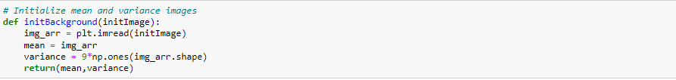
3. Function for Foreground Detection and Voting scheme(to reduce noise):
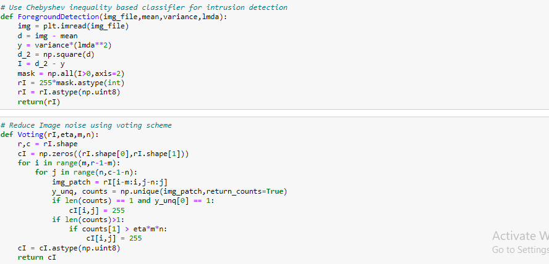

4. Define Background Subtraction:
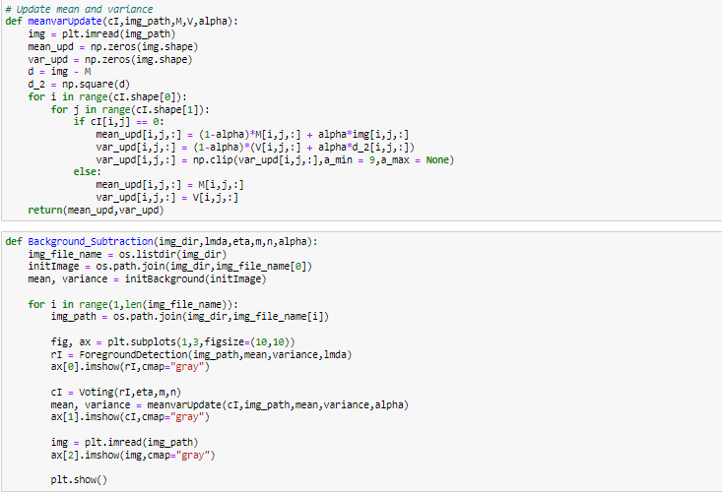
5. Implement Intrusion Detection:
